Lab Assignment-10.5
Name: Ashwitha
Hall ticket:2303A51340
Batch:20
Task 1:
Prompt:
“Rewrite the Python function using meaningful function and variable names. Improve readability and follow PEP 8 naming conventions.”
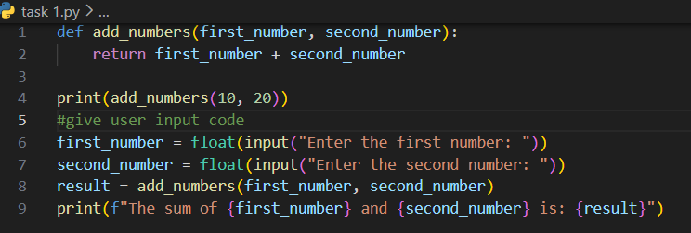
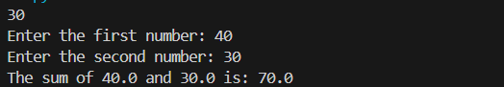
Analysis:
The original function used unclear names, making the code difficult to understand.
AI improves readability by replacing short variable names with meaningful ones.
Descriptive naming helps programmers quickly understand the function’s purpose.
It also reduces confusion when the program becomes larger.
Following PEP 8 naming standards improves consistency in coding style.
Overall, the refactored code becomes easier to read and maintain.
Task 2
Prompt:
“Refactor the Python division function to include proper exception handling, user-friendly error messages, and safe execution.”
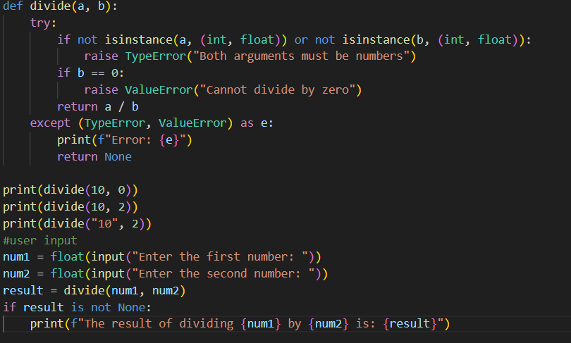
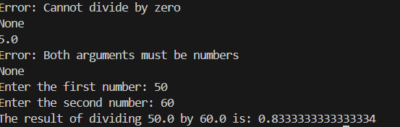
Analysis:
The original program crashes when division by zero occurs.
AI adds exception handling to prevent runtime errors.
Clear error messages improve user understanding of failures.
This makes the program more reliable in real-world usage.
Error handling also improves debugging and maintainability.
Thus, the updated code becomes safer and more robust.
Task3
Prompt:
“Refactor this student marks program to follow PEP 8 standards. Use functions, meaningful names, comments, and input validation.”
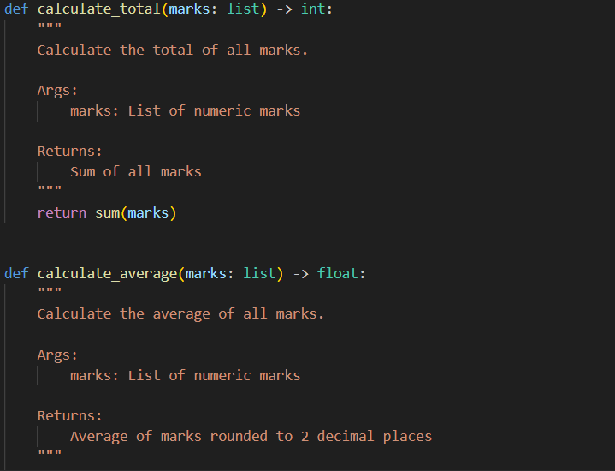
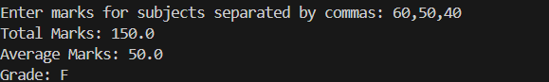
Analysis:
The initial code had poor formatting and no modular structure.
AI refactors it into functions with meaningful variable names.
PEP 8 formatting improves readability and coding standards compliance.
Input validation prevents incorrect data from causing issues.
Comments and structure make the logic easier to follow.
The improved version is reusable, maintainable, and clearer.
Task4
Prompt:
“Add a proper docstring explaining parameters, return value, and purpose. Also include inline comments for clarity.”
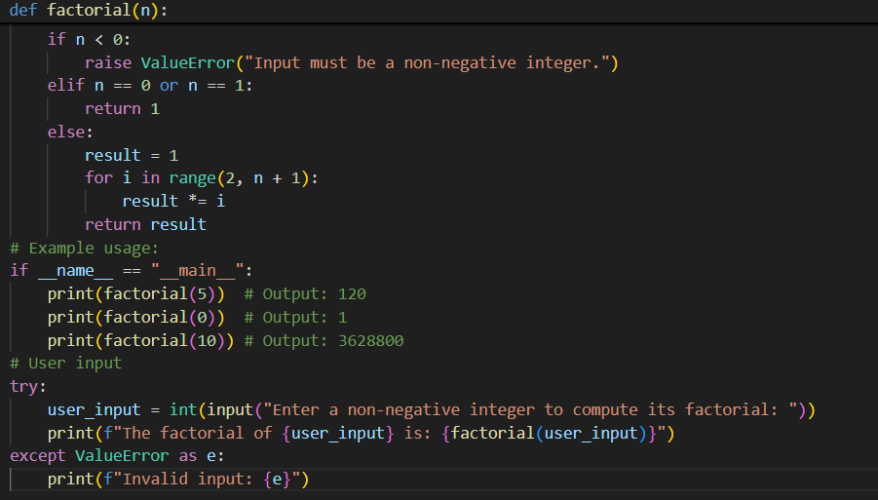
Analysis:
The original function worked correctly but lacked documentation.
AI adds a docstring explaining inputs, outputs, and purpose.
Inline comments clarify the working of loops and calculations.
This helps other developers understand the function quickly.
Documentation improves maintainability and code reuse.
Hence, the function becomes more professional and readable.
Task5
Prompt:
“Rewrite the password validation program to include multiple security rules (uppercase, lowercase, digit, special character). Follow PEP 8, use functions, docstrings, and comments. Then explain how the improved version enhances security and maintainability.”
Analysis:
The original program only checked password length, which is insecure.
AI adds checks for uppercase, lowercase, digits, and special characters.
This greatly improves password strength and security.
The refactored version uses functions, comments, and docstrings.
Better structure makes the code reusable and easier to modify.
Thus, the improved program is more secure, structured, and reliable.
